Tahoe National Forest Managed Viewsheds
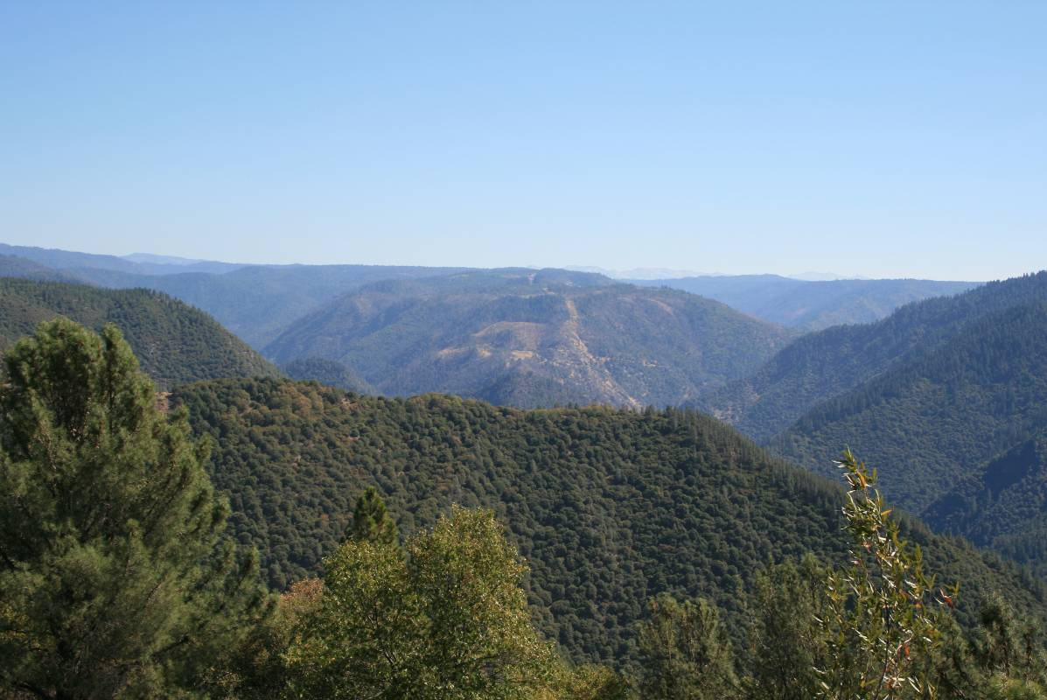
Photo 1. View of Project facilities above Ralston Powerhouse on Ralston Ridge as seen from Mosquito Ridge Road, looking southeast.
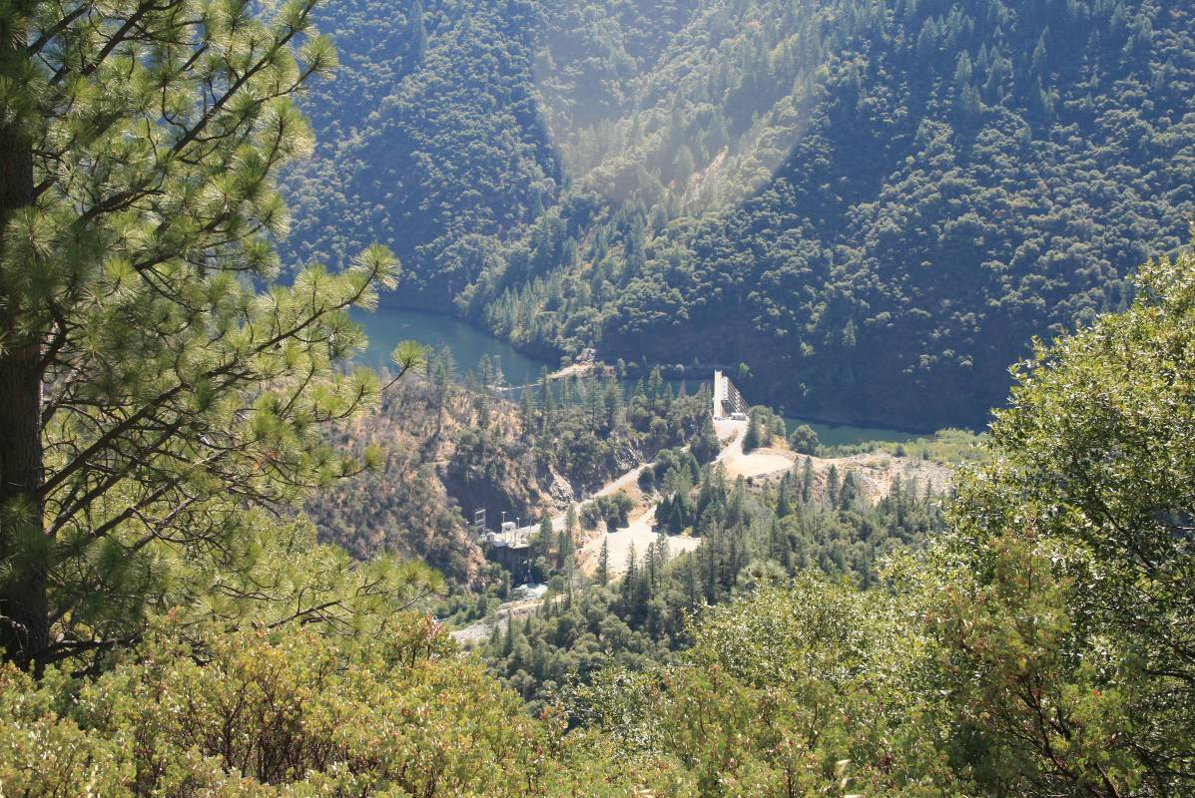
Photo 2. View of Ralston Afterbay Dam and associated features from Mosquito Ridge
Road.
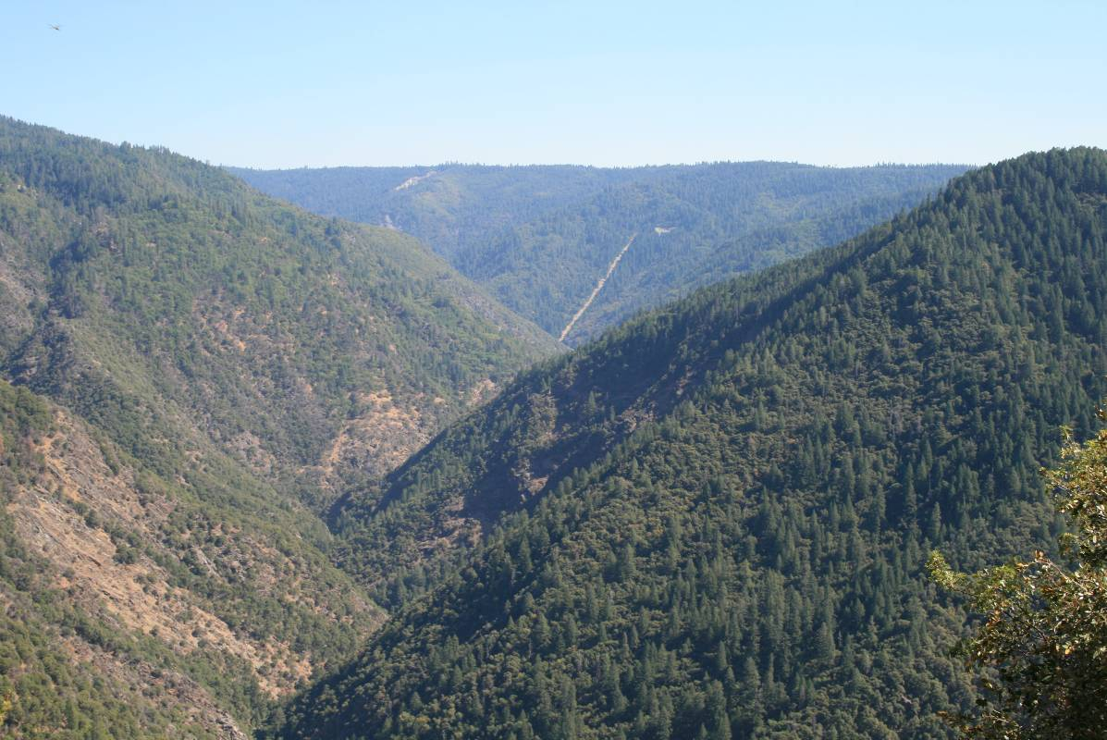
Photo 3. View of Middle Fork Powerhouse Penstock from Mosquito Ridge Road near
Dutch Flat.
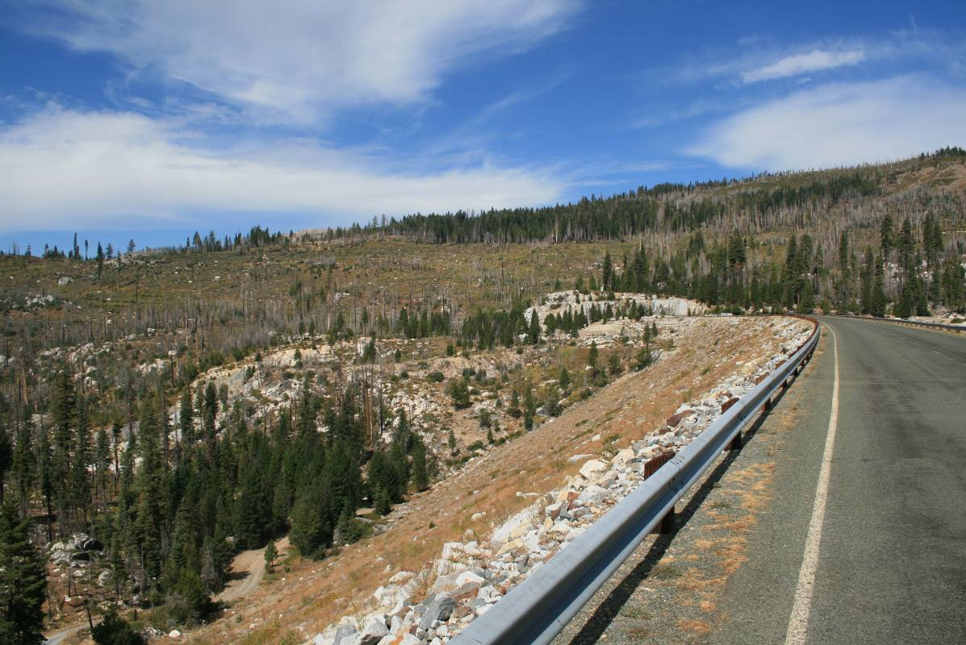
Photo 4. View of French Meadows Dam and below, from Mosquito Ridge Road (FR 96)
near its intersection with Soda Springs - Riverton Road (FR 22).
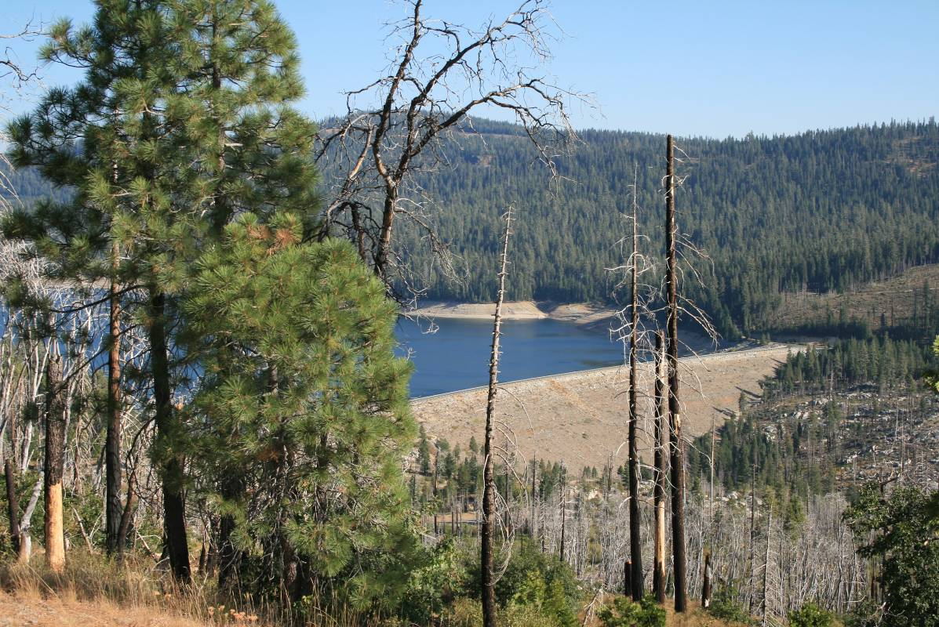
Photo 5. View of French Meadows Dam and Reservoir as seen from near the junction of
the Tevis Cup Trail and the Western States Trail.
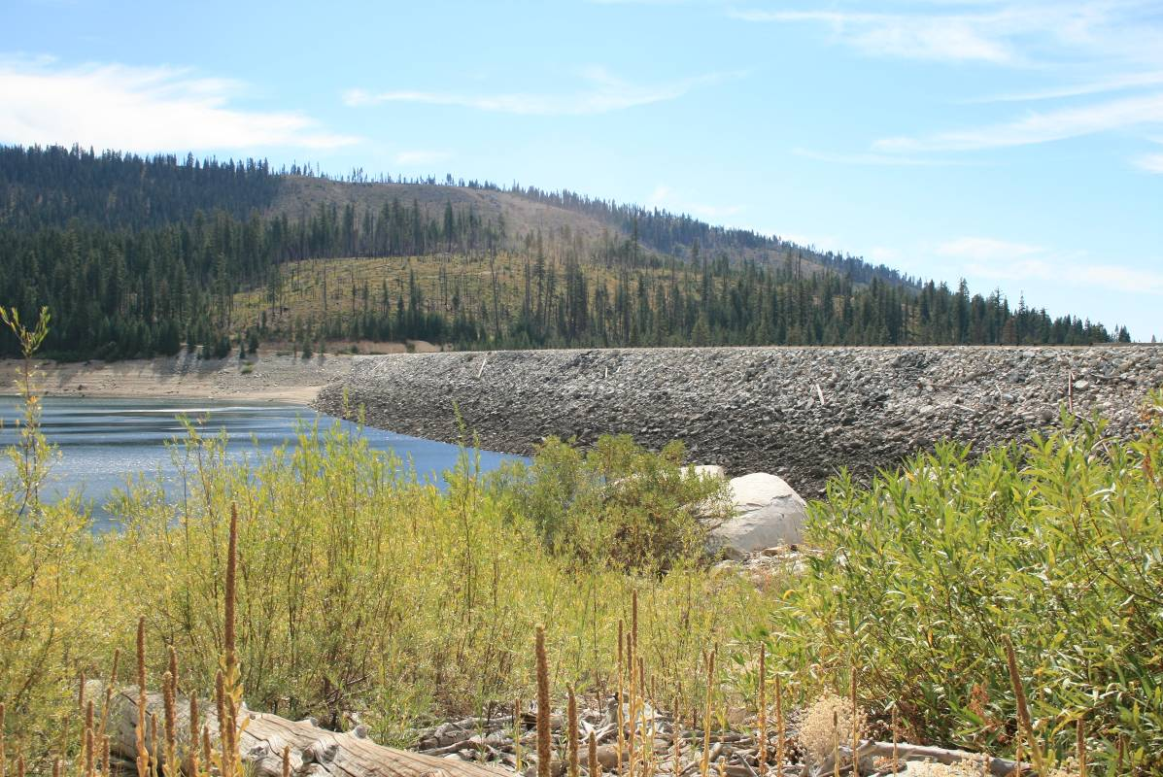
Photo 6. View of upstream side of French Meadows Dam from French Meadows Reservoir viewshed (near Spillway), looking south.
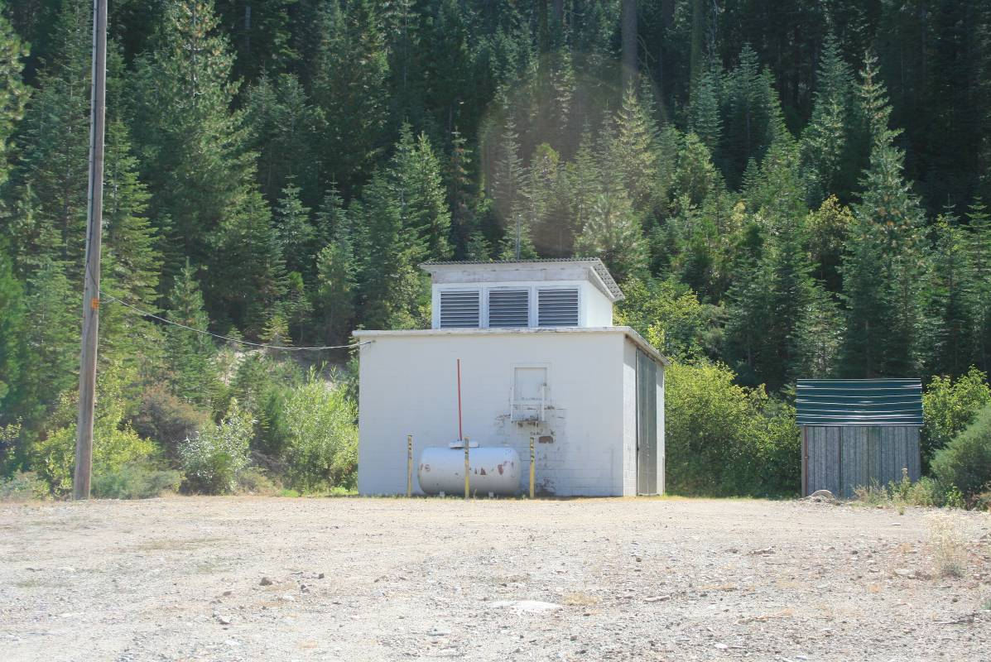
Photo 7. View of French Meadows-Hell Hole Tunnel Gatehouse from French Meadows Reservoir viewshed.
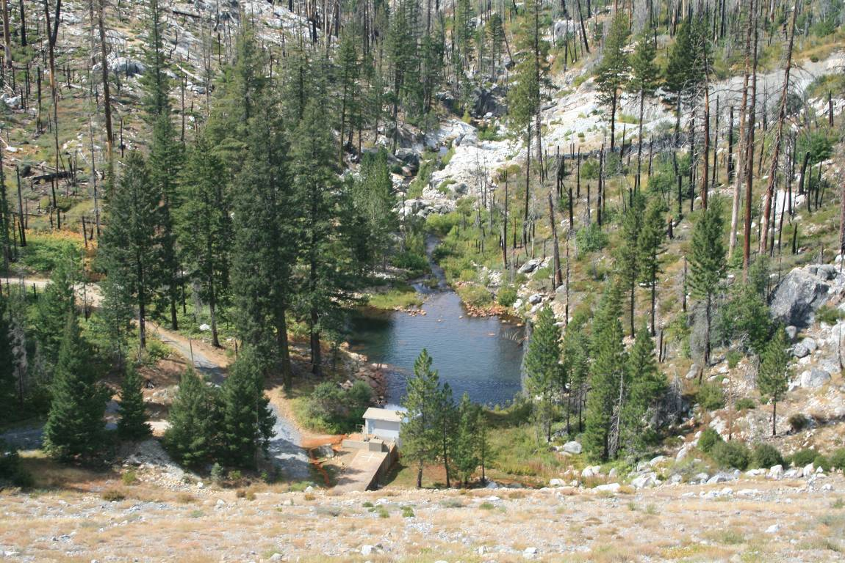
Photo 8. View of Middle Fork American River viewshed immediately downstream of
French Meadows Dam.
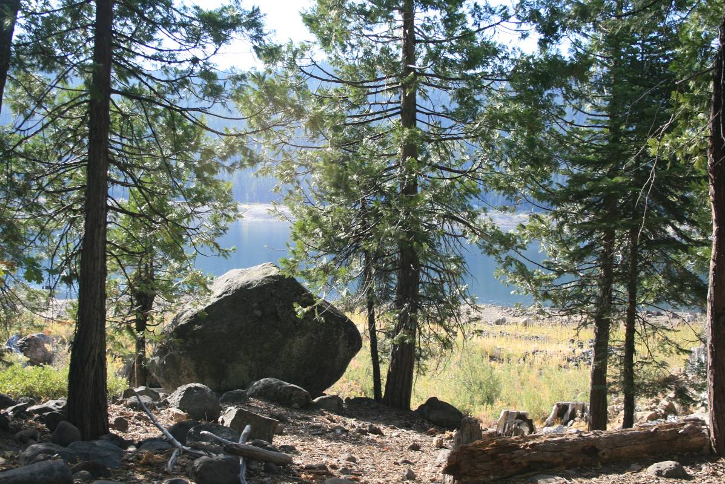
Photo 9. View from Poppy Campground, looking south across reservoir towards French Meadows Boat Ramp and French Meadows - Hell Hole Tunnel Gatehouse.
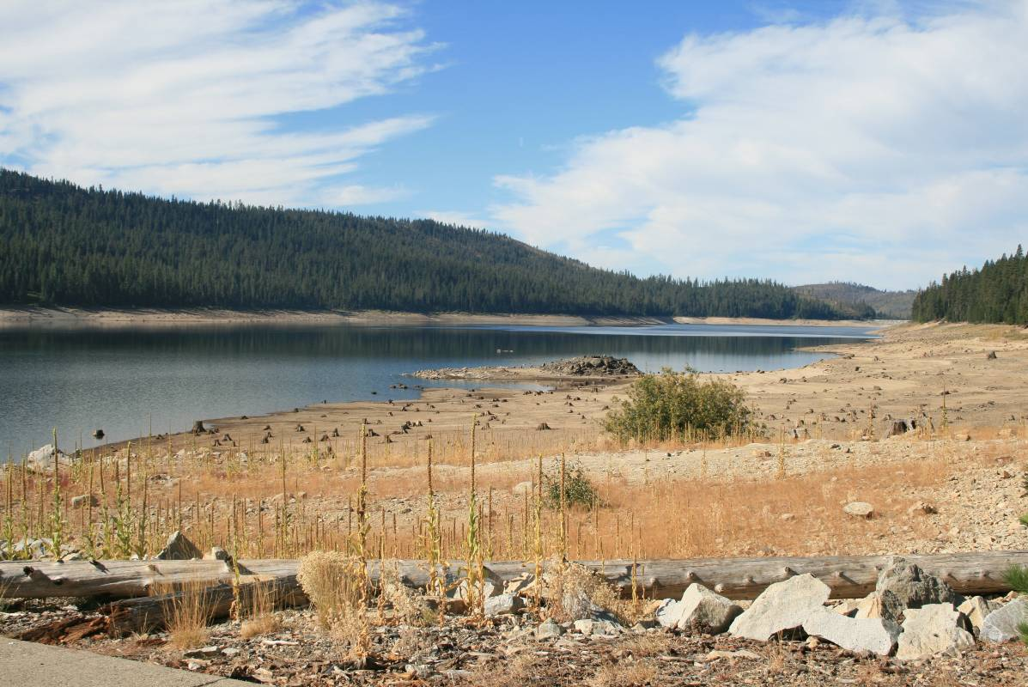
Photo 10. View of French Meadows Dam looking west from McGuire Boat Ramp.

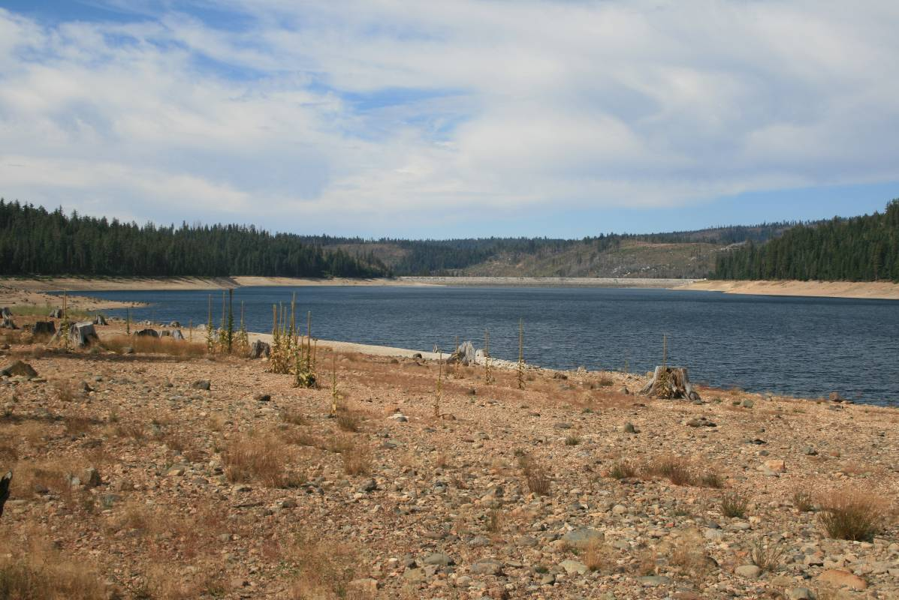
Photo 11. View of French Meadows Dam looking west from French Meadows Boat Ramp.
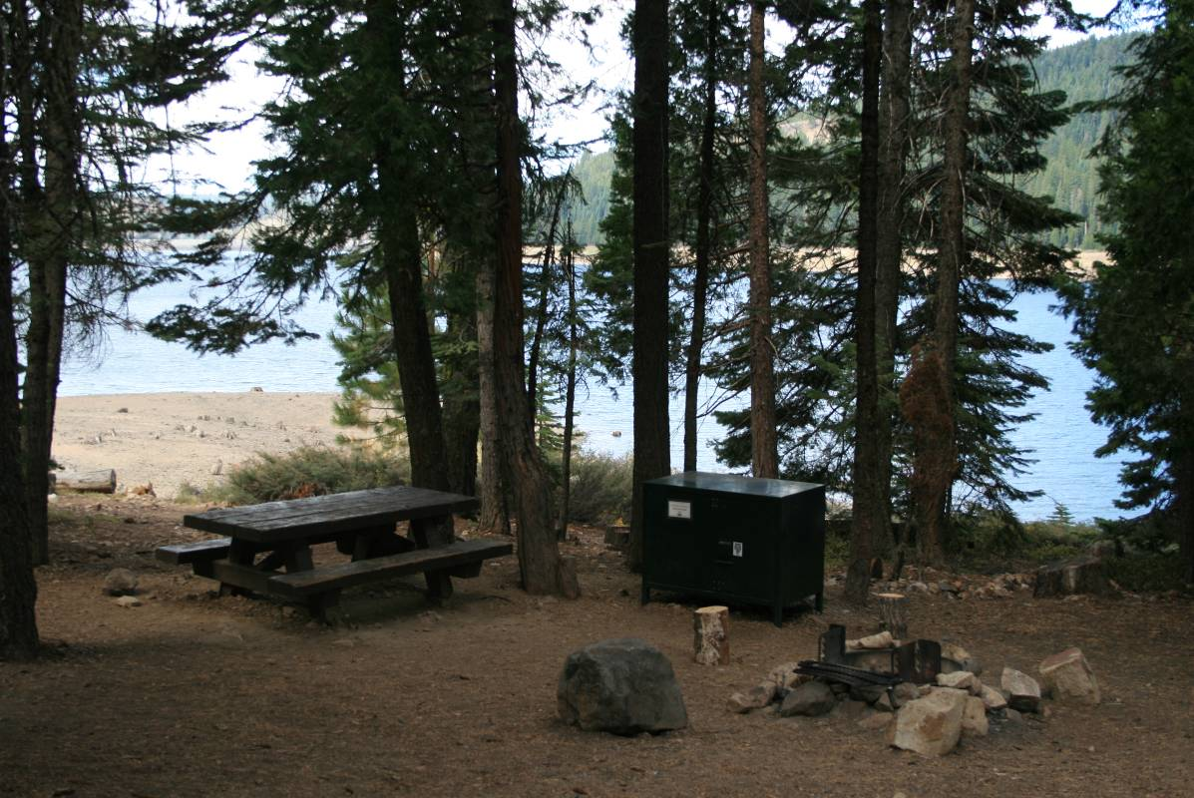
Photo 12. View towards French Meadows Dam from French Meadows Campground.

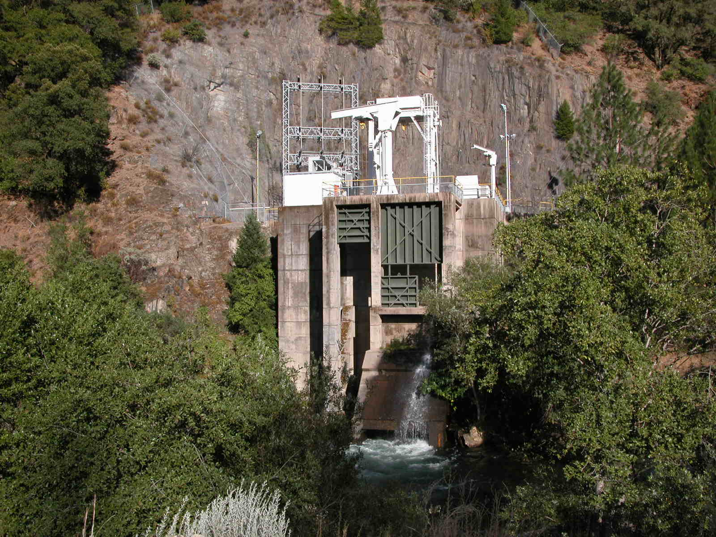
Photo 13. View of Oxbow Powerhouse and Switchyard from near the Indian Bar Rafter
Put-in.

